FEB 2026 version

ID: _

(PARAMETERS) | PHASE I | PHASE II
Site | HAND (PALM)
Laterality | RIGHT
Verified Rx in Sensus EMR
Cumulative DOSE | Gy | (cGy) | Gy | (cGy)
Dose per PHASE | Gy | (cGy) | Gy | (cGy)
Dose per FRACTION | _ cGy/fx prescribed to ___  surface at extended SSD | _ cGy/fx prescribed to _  surface at extended SSD
Total Fraction no. | 5 fractions | 5 fractions
Time | _ minutes | _ minutes
Energy | 100 kV  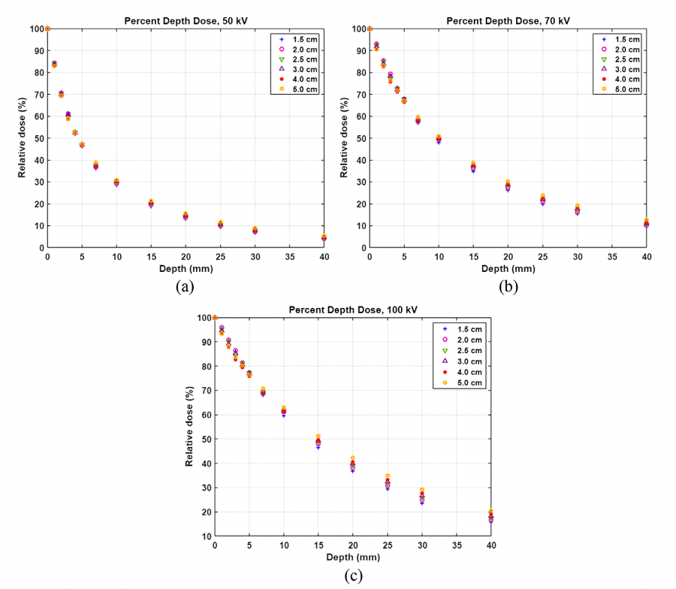 | 100 kV  
SSD (for calculation) | SSD (for calculation)  EXTENDED | SSD (for calculation)  EXTENDED
SSD (cm) | 25cm (10cm applicator) vs.  30 cm (8x18cm applicator)  + 10cm hand applicator =  35 vs 40 cm minus hand thickness | 25cm (10cm applicator) vs.  30 cm (8x18cm applicator)  + 10cm hand applicator =  35 vs 40 cm minus hand thickness
Hand thickness (measured) | cm (by caliper) | cm (by caliper)
Hand thickness (for calculation) | Hand Thickness (for calculation) | Hand Thickness (for calculation)
Applicator size | Applicator Size | Applicator Size
SPECIAL PHYSICS CALCULATION
Margin | Custom | Custom
Technique | DEEP (Depth Enabled)  Prescription Dose Specification | DEEP (Depth Enabled)  Prescription Dose Specification
Lead Shield #1 Size | __ cm field  EXTENDED SSD | __ cm field  EXTENDED SSD
Lead Shield #2 Size | Leaded covering over hand applicator | Leaded covering over hand applicator
Lead Shield #3 Size | Shield #3 | Shield #3
Thyroid Shield | YES | YES
Lead Apron | YES | YES
Nasal Bullet | None | None
Eye Shield Interior | None | None
Eye Shield Exterior | LEADED GLASSES  LEADED covering over HAND APPLICATOR | LEADED GLASSES  LEADED covering over HAND APPLICATOR
Lead Glasses | YES  LEADED GLASSES  LEADED covering over HAND APPLICATOR | YES  LEADED GLASSES  LEADED covering over HAND APPLICATOR
Dose Rate | per plan | per plan
Beam Arrangement | En Face Kilovoltage Photons | En Face Kilovoltage Photons
Shielding Design(s) | Custom | Custom
Fractions per day | 1 | 1
Fractions per week | 5  THU (film)  TUE, WED, THU, FRI | 5  THU (film)  TUE, WED, THU, FRI
Single or Multi phase | Single Phase | Phase II  8 weeks later
Synchronous vs Sequential | Sequential | Sequential
Imaging (77439 US) | 20 mHz: Daily isodose tracking dose to depth  12 MhZ: Weekly for comprehensive IGSRT | 20 mHz: Daily isodose tracking dose to depth  12 MhZ: Weekly for comprehensive IGSRT
Alignment | Align drawn field | Align drawn field
Custom Block | NO | NO
Complex Shielding (77263) | NO | NO
In Vivo Dosimetry/Film | FILM on day 1 | FILM on day 1
GRID (Spatial Fractionation) | NO | NO
Concurrent Therapy | NO | NO
Pre-Authorized | NA | NA
Consult Images
SIM ORDER Drawn Target
Sim Image:
Inked Target
Sim Image:
Shielded nozzle view
Sim Image:
Side nozzle view
Depth of Target (DOT) (Ultrasound) | Depth of Target (DOT): _
Estimated tumor a/b* | 10 | 10
EQD2 for tumor (a/b_10)
EQD2 for OARs (a/b_3)
BED for tumor (a/b_10)
BED for OARs (a/b_3)
Electronically Signed by: | Clayton B. Hess, MD, MPH  Radiation Oncologist
Date Ordered: | Feb 24, 2026

